Evaluating Frozen Foundation Model Embeddings for Morphological Correlation and Survival Analysis

Abstract
Whole slide images (WSIs) contain complex cellular and tissue-level information that can support computational pathology research. Deep learning models can transform histopathological images into numerical feature representations, or embeddings, which can subsequently be used for clustering and downstream prediction tasks. However, the usefulness of these representations may vary depending on the evaluation method and the downstream task.
This project presents a comparative evaluation of feature representations generated by UNI and GIGA using clustering analysis and multiple instance learning (MIL) for survival analysis. First, feature representations are extracted using both models. Cell-level ground-truth information, including cell types and spatial coordinates, is generated from WSIs using CellViT. K-Means clustering with five clusters is then applied to the extracted representations. Clustering quality is investigated using Principal Component Analysis (PCA), silhouette scores, and comparisons between cluster assignments and CellViT-derived cell-type distributions.
Furthermore, the representations generated by UNI and GIGA are evaluated using two MIL methods: Attention-Based Multiple Instance Learning (ABMIL) and Clustering-constrained Attention Multiple Instance Learning (CLAM). Their downstream performance is assessed using Kaplan–Meier survival curves, the concordance index (C-index), and Cox loss. The overall objective is to investigate the structural characteristics, biological interpretation, and downstream survival-analysis performance of the two feature representations.
Keywords: Computational pathology, whole slide images, UNI, GIGA, CellViT, feature embeddings, K-Means, PCA, multiple instance learning, ABMIL, CLAM, survival analysis.

1. Introduction

1.1 Background
Histopathological image analysis is an important part of computational pathology. It involves the examination of tissue images to identify cellular structures, tissue patterns, and other biological characteristics. With the development of deep learning, automated methods can process digital pathology images and extract information that may be difficult to quantify manually.
Whole slide images are high-resolution digital representations of tissue sections. Their large size and structural complexity make direct analysis challenging. Consequently, computational pathology pipelines commonly divide WSIs into smaller image patches and process these patches using deep learning models.
Feature extraction models transform image information into numerical representations called embeddings. These embeddings encode visual patterns that can be used for downstream tasks, including clustering, classification, and survival analysis. The quality and usefulness of an embedding depend on how well it captures information relevant to the task being investigated.
UNI and GIGA are the two feature representation models considered in this project. Rather than developing a new representation model, the project focuses on comparing the representations produced by these existing models through multiple experiments.

1.2 Problem Statement
Histopathological images contain complex cellular and tissue-level information. Although feature representation models such as UNI and GIGA can transform these images into numerical embeddings, the embeddings cannot be fully evaluated by feature extraction alone.
Different evaluation methods provide different perspectives on representation quality. Clustering analysis can reveal the structure of the embeddings, while comparisons with cell-level ground truth can help determine whether the resulting clusters contain meaningful biological patterns. Downstream survival analysis can further investigate whether the representations are useful for patient-level risk prediction.
Therefore, a systematic comparison is needed to investigate the characteristics and usefulness of UNI and GIGA representations across clustering analysis, biological interpretation, and MIL-based survival analysis.

1.3 Aim
The main aim of this project is to evaluate and compare UNI and GIGA feature representations using unsupervised clustering, CellViT-derived cell-level ground truth, and downstream MIL methods for survival analysis.

1.4 Objectives
The objectives of the project are:
- Extract feature representations from histopathological data using UNI and GIGA.
- Generate cell-level ground-truth information from WSIs using CellViT.
- Apply K-Means clustering to the extracted feature representations.
- Evaluate clustering behavior using PCA visualization and silhouette scores.
- Compare cluster-level cell-type distributions with CellViT-derived ground truth.
- Evaluate both feature representations using ABMIL and CLAM.
- Assess survival-analysis performance using Kaplan–Meier curves, C-index, and Cox loss.
- Compare UNI and GIGA across the clustering and survival-analysis experiments.
- Identify the strengths, limitations, and differences observed in the experimental results.

1.5 Scope of the Project
The project focuses on comparative evaluation rather than the development of a new feature extraction architecture. The experimental work includes feature extraction, cell-level ground-truth generation, unsupervised clustering, biological interpretation of clusters, and MIL-based survival analysis.
The clustering experiments investigate the organization of feature representations and their relationship with cell types. The survival experiments investigate the usefulness of these representations in downstream patient-level survival prediction.
The conclusions are based on the experiments performed and should be interpreted within the limitations of the datasets, experimental configuration, and evaluation metrics.

2. Related Work

2.1 Deep Learning for Computational Pathology
Deep learning has become an important approach for analyzing histopathological images. These methods can learn visual representations from tissue images and provide numerical features for subsequent analysis.
Because WSIs can contain billions of pixels, processing an entire slide at once is often impractical. Patch-based pipelines address this challenge by dividing a slide into smaller regions and extracting features from each region. The resulting patch embeddings can then be aggregated or analyzed using different computational methods.

2.2 Feature Representation Models: UNI and GIGA
Feature representation models are designed to encode image information into numerical vectors. These vectors provide a compact representation of visual patterns and can be used as inputs to clustering algorithms and downstream predictive models.
In this project, UNI and GIGA are evaluated as alternative sources of histopathological image representations. Both models are used to generate embeddings, and their outputs are evaluated under comparable experimental conditions.
The comparison is important because representation quality is task-dependent. A model that produces clearly separated clusters does not necessarily provide the best results for survival prediction. Therefore, multiple complementary experiments are required to develop a broader understanding of the representations.

2.3 Cell-Level Analysis Using CellViT
Cell-level information can provide a biological reference for analyzing histopathological image representations. CellViT is used in this project to process WSIs and produce cell-level information, including predicted cell types and spatial coordinates.
This information is used as ground truth for the project's cluster-composition analysis. The cell types identified by CellViT provide a reference against which the composition of the clusters can be examined.
Because CellViT is a computational model, its outputs should be understood as model-derived reference annotations unless they have been independently verified against expert annotations.

2.4 Unsupervised Clustering
Clustering groups observations according to similarities in their feature representations. K-Means is a widely used unsupervised clustering algorithm that partitions observations into a predefined number of clusters.
In this project, K-Means is applied with K = 5, corresponding to the five cell types considered in the CellViT-based analysis. The purpose is to investigate whether the feature representations naturally organize into groups whose cell-type compositions correspond to the available reference information.
The number of clusters does not guarantee that each cluster will represent exactly one cell type. The correspondence must be examined through the experimental results.

2.5 Multiple Instance Learning for Survival Analysis
Multiple instance learning is useful when a single prediction is associated with a collection of instances rather than an individual instance. In computational pathology, image patches can serve as instances, while a WSI or patient-level sample can be represented as a bag of patches.
ABMIL uses attention mechanisms to assign different importance weights to instances when producing a bag-level representation. CLAM extends attention-based MIL with additional clustering constraints on instance-level representations.
In this project, both methods are applied to UNI and GIGA embeddings. This design allows the two representation models to be compared using the same downstream learning methods.

2.6 Survival Analysis Metrics
Survival analysis examines the time until an event occurs, such as death. Its evaluation must account for censored observations, where the event has not been observed during the available follow-up period.
Three evaluation approaches are considered in this project:
- Kaplan–Meier curves: Estimate and visualize survival probability over time, often comparing predicted risk groups.
- Concordance index (C-index): Measures how well a model ranks patients according to survival risk, accounting for comparable censored survival observations.
- Cox loss: An optimization objective used to train survival models under the Cox proportional hazards framework.
Together, these approaches provide complementary information about model training, risk ranking, and survival patterns.

3. Methodology

3.1 Overview of the Experimental Pipeline
The project follows a multistage experimental pipeline.
First, UNI and GIGA are used to extract feature representations from histopathological data. In parallel, CellViT processes the WSIs to generate cell-level information. The embeddings are then evaluated using K-Means clustering, PCA visualization, and silhouette scores.
Next, CellViT-derived cell-type information is used to investigate the biological composition of the resulting clusters. Finally, both feature representations are evaluated using ABMIL and CLAM for survival analysis.
The overall pipeline is:
Histopathological images → Feature extraction → Clustering and biological evaluation → MIL survival analysis → Comparative evaluation

3.2 Feature Extraction
The first stage generates feature representations using UNI and GIGA.
Each model transforms the input image information into numerical embeddings. These embeddings are used as the input representations for the subsequent clustering and MIL experiments.
The same general evaluation strategy is applied to both models so that their outputs can be compared across multiple tasks.
The feature extraction stage does not itself establish whether one representation is superior. That question is investigated through the downstream experiments.

3.3 Ground-Truth Generation Using CellViT
CellViT is applied to WSIs to identify individual cells and generate cell-level information. The resulting information includes:
- Cell type.
- Spatial coordinates of detected cells.
The cell-type labels and coordinates are organized as the ground-truth reference for the subsequent cluster-composition analysis.
Cell types provide the biological categories used to examine the clusters, while spatial coordinates retain information about where cells occur within the tissue.
The CellViT output and the UNI/GIGA embeddings serve different purposes. CellViT provides the reference cell-level information, whereas UNI and GIGA provide the feature representations being evaluated.

3.4 K-Means Clustering
K-Means clustering is applied to the extracted feature representations to investigate their organization in feature space.
The number of clusters is set to five (K = 5), based on the five cell types considered in the CellViT-derived ground-truth analysis.
K-Means groups observations according to their distances from cluster centroids. The algorithm uses the feature representations to form clusters; the CellViT cell-type labels are not used to direct the clustering itself.
After clustering, each observation has an assigned cluster identifier. These identifiers are subsequently analyzed using the clustering metrics and cell-type information.
It is important to distinguish the number of clusters from the biological interpretation of those clusters. Setting K = 5 does not ensure that the five resulting clusters correspond one-to-one with the five cell types.

3.5 Clustering Evaluation
Two complementary methods are used to evaluate clustering behavior: PCA visualization and silhouette score.

3.5.1 Principal Component Analysis
Principal Component Analysis is a dimensionality-reduction technique that transforms high-dimensional data into a smaller number of components while preserving as much variance as possible under the chosen linear projection.
In this project, PCA is used to visualize the high-dimensional embeddings in a lower-dimensional space, typically two dimensions. The resulting plots allow visual inspection of the distribution and overlap of the clusters.
PCA is a visualization and dimensionality-reduction method rather than a direct measure of clustering quality. Apparent separation in a two-dimensional plot does not necessarily imply that clusters are well separated in the original feature space.

3.5.2 Silhouette Score
The silhouette score measures how well each observation fits within its assigned cluster relative to other clusters. It considers the distance between an observation and points in its own cluster, as well as its distance from points in neighboring clusters.
The score generally ranges from -1 to +1:
- Values closer to +1 indicate that observations are well matched to their assigned clusters and separated from neighboring clusters.
- Values around 0 indicate overlapping clusters or observations near cluster boundaries.
- Negative values may indicate that observations are closer to another cluster than to their assigned cluster.
Silhouette scores are calculated and compared for the representations under investigation. The scores provide a quantitative perspective that complements PCA visualization.

3.6 Comparison of Clusters with CellViT Ground Truth
After clustering, the cell-type composition of each cluster is investigated using the CellViT-derived ground truth.
The procedure is as follows:
- Identify the patches or observations assigned to each K-Means cluster.
- Collect the patches belonging to the same cluster.
- Retrieve the CellViT-derived cell-type information associated with those patches.
- Count the cells belonging to each cell type within each cluster.
- Compare the resulting cell-type distributions across the clusters.
For example, if a cluster contains a large proportion of tumor cells compared with other cell types, it may be described as enriched in tumor cells.
The interpretation depends on the observed distribution. A cluster should not be described as exclusively representing a particular cell type unless the experimental evidence supports that conclusion.
This analysis complements the silhouette score. While the silhouette score evaluates geometric clustering structure, the CellViT comparison investigates whether the clusters have meaningful cell-type compositions.

3.7 Multiple Instance Learning
The downstream experiments evaluate the usefulness of UNI and GIGA embeddings for survival analysis using two MIL methods: ABMIL and CLAM.
Four experimental combinations are considered:
- UNI embeddings with ABMIL.
- UNI embeddings with CLAM.
- GIGA embeddings with ABMIL.
- GIGA embeddings with CLAM.

3.7.1 Attention-Based Multiple Instance Learning
ABMIL uses an attention mechanism to assign importance weights to instances within a bag. These weights contribute to the aggregation of instance-level features into a bag-level representation.
In the pathology setting, a bag can represent a patient or WSI, while its instances represent image patches. The aggregated representation is used for the downstream prediction task.

3.7.2 Clustering-constrained Attention Multiple Instance Learning
CLAM is an attention-based MIL approach that incorporates clustering constraints at the instance level. These constraints encourage the model to learn more structured instance representations while performing bag-level prediction.
Using CLAM alongside ABMIL allows the comparison to consider two different MIL approaches rather than relying on a single downstream method.

3.7.3 Comparative Design
Both UNI and GIGA are evaluated using both ABMIL and CLAM. This creates a four-combination experimental design that helps investigate the effect of the feature representation and the MIL method.
For a fair comparison, relevant conditions—including patient splits, training procedures, and evaluation settings—should be kept consistent wherever possible. Any differences in configuration should be documented when reporting the results.

3.8 Survival-Analysis Evaluation
The MIL models are evaluated using Kaplan–Meier survival curves, C-index, and Cox loss.

3.8.1 Kaplan–Meier Survival Curves
Kaplan–Meier curves estimate the probability of surviving beyond a given time. They can be used to visualize survival differences between groups of patients.
In this project, the curves are used to examine the survival patterns of groups defined using the model's predicted risk scores, according to the grouping procedure adopted in the experiments.
Clear separation between the curves may indicate that the model distinguishes groups with different observed survival patterns. However, visual separation should be interpreted alongside the sample size, censoring, uncertainty, and other available statistical evidence.

3.8.2 Concordance Index
The C-index evaluates the ability of a survival model to rank patients correctly according to their relative risk.
A value of approximately 0.5 generally corresponds to chance-level ranking, while a value closer to 1 indicates stronger concordance. Interpretation depends on the exact definition and implementation used.
The C-index is an evaluation metric rather than a training loss. It is used to compare the survival-risk ranking performance of the UNI and GIGA representations when paired with ABMIL and CLAM.

3.8.3 Cox Loss
Cox loss is used to optimize a survival model under the Cox proportional hazards framework. It encourages the model to learn risk scores that are consistent with the observed event times and censoring information.
Unlike the C-index, which evaluates ranking performance, Cox loss is primarily a training objective. Its numerical value should be compared cautiously because it may depend on the dataset, risk-set construction, implementation, and loss normalization.

3.9 Comparative Evaluation Strategy
The project evaluates the representations from three complementary perspectives:
- Feature-space structure: PCA visualization and silhouette scores.
- Biological interpretation: Cell-type distributions within the K-Means clusters.
- Downstream survival analysis: ABMIL and CLAM performance using survival metrics.
Considering these perspectives together provides a broader evaluation than relying on any single metric. In particular, strong clustering performance does not automatically imply strong survival-prediction performance because the experiments measure different properties of the representations.

4. Experimental Setup

4.1 Dataset
The project investigates histopathological data for (LUAD,LUSC,KIRP,KIRC,BRCA) survival analysis. The experimental work flow uses WSIs and associated patient-level survival information.
The project includes multiple datasets or experimental dataset configurations. The final report should identify each dataset explicitly and describe its sample count, data source, inclusion criteria, and relevant clinical information.
Where multiple dataset configurations are used, their results should be reported separately before drawing conclusions across datasets.

4.2 Feature Representations
UNI and GIGA are used to generate the feature embeddings. The embeddings are then supplied to the clustering and MIL pipelines.
The final report should document the exact model versions or checkpoints, embedding dimensions, patch extraction procedure, and any feature normalization applied.
Component | Configuration
Feature representation models | UNI and GIGA
Clustering algorithm | K-Means
Number of clusters | K = 5
Dimensionality reduction | PCA
Clustering evaluation | Silhouette score
Cell-level reference | CellViT
MIL methods | ABMIL and CLAM
Survival evaluation | Kaplan–Meier, C-index, Cox loss

4.3 Ground-Truth Generation
CellViT is used to process the WSIs and generate cell-type labels and spatial coordinates. These outputs provide the reference information for the cell-type composition analysis.
The final report should document the CellViT version or checkpoint, the five cell types considered, and how the cell-level outputs are associated with the patches or observations used in clustering.

4.4 Clustering Configuration
K-Means is applied with five clusters. PCA is used to visualize the feature representations, and silhouette scores are used to quantify clustering structure.
For reproducibility, the final report should include the clustering implementation, distance metric, initialization settings, random seed, and any preprocessing performed before clustering.

4.5 MIL Configuration
Both ABMIL and CLAM are evaluated with UNI and GIGA embeddings, producing four experimental combinations.
The final report should specify the model configurations, training parameters, optimizer, learning rate, number of epochs, batch or bag construction, and any early-stopping procedure. It should also state how patient-level data partitions were maintained to avoid information leakage between training and evaluation.

4.6 Evaluation Protocol
The clustering experiments use PCA visualizations and silhouette scores, followed by analysis of cell-type composition.
The survival experiments use Kaplan–Meier curves, C-index, and Cox loss. The final report should state which partition was used for each reported metric and whether the values represent training, validation, or test performance.
Any comparisons should use the same evaluation protocol wherever possible. Model selection should not be based on test-set performance if the test set is intended for final independent evaluation.

5. Results
Note: This section must be completed using the final experimental outputs. Numerical values, dataset-specific rankings, and claims about which representation performs better should not be inferred without the corresponding results.

5.1 Feature Extraction
UNI and GIGA were used to generate feature representations for the subsequent experiments.
The resulting embeddings served as inputs to the clustering and MIL analyses. This provided a consistent basis for investigating differences between the representations through unsupervised structure analysis and downstream survival prediction.
The final version of this section should report the embedding dimensions, number of samples or patches processed, and any relevant differences in the extraction procedure.

5.2 Clustering Evaluation
The feature representations were analyzed using K-Means with K = 5. PCA visualizations were generated to inspect the distribution of the resulting clusters, and silhouette scores were calculated to quantify clustering quality.
PCA findings:
UNI BRCA, KIRP, LUAD, LUSC
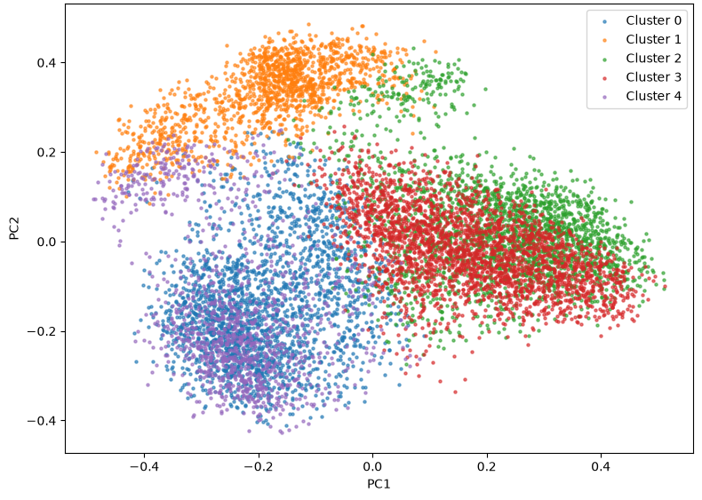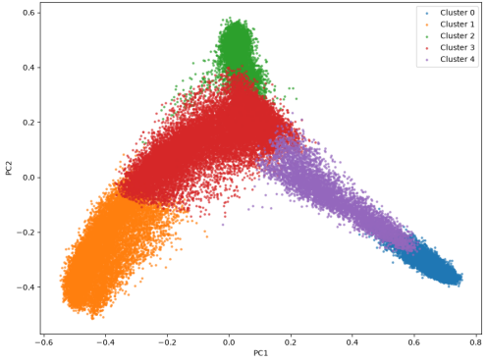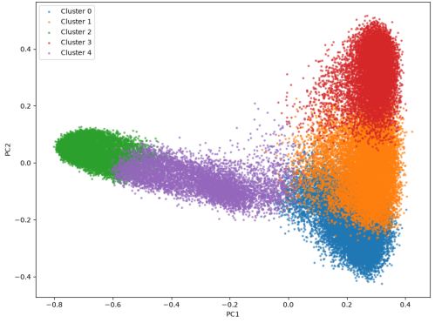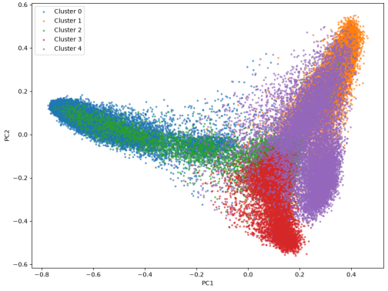

GIGA KIRC, KIRP, LUAD, LUSC
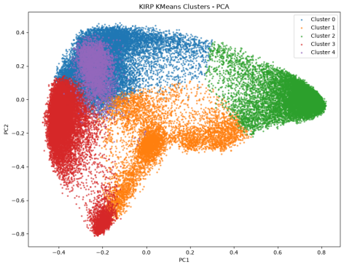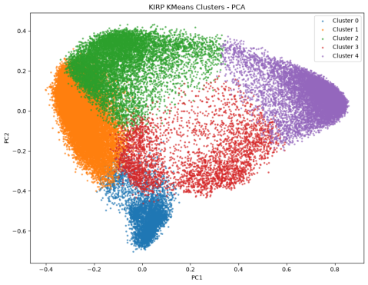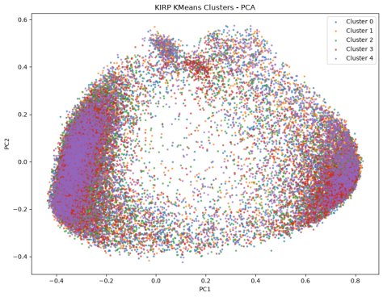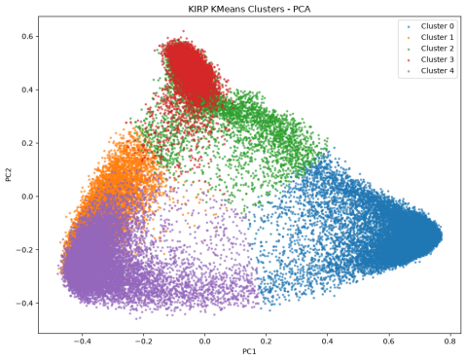

Silhouette scores:
Dataset | UNI silhouette score | GIGA silhouette score
LUAD | 0.0913 | 0.1192
LUSC | -0.0090 | 0.1289
KIRP | 0.1161 | 0.1073
BRCA | 0.0393
KIRC |  | 0.1412
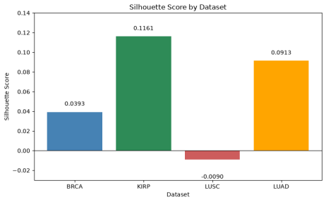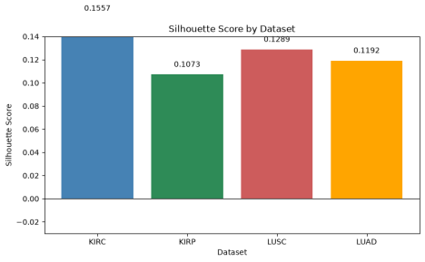
The comparison should identify which representation achieves higher silhouette scores for each dataset and whether the visualizations support the same interpretation. Differences should be discussed without assuming that a higher silhouette score necessarily indicates better biological or survival-analysis performance.

5.3 Cell-Type Composition of Clusters
The CellViT-derived cell types were counted within the patches assigned to each K-Means cluster. The resulting distributions were used to investigate the biological composition of the clusters.
Observed findings:
UNI: LUSC, BRCA, KIRP, LUAD
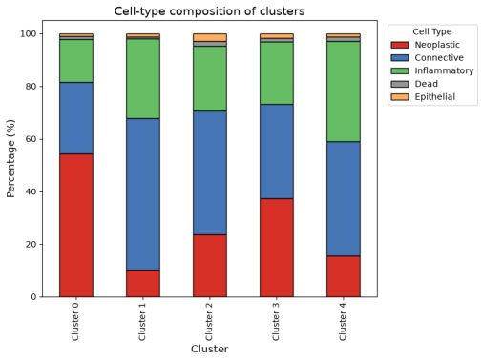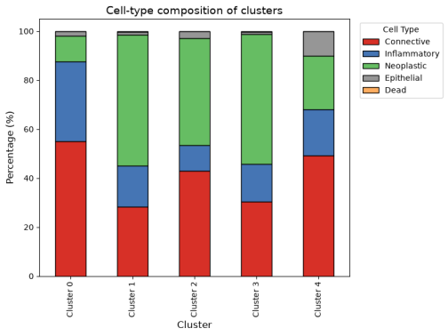
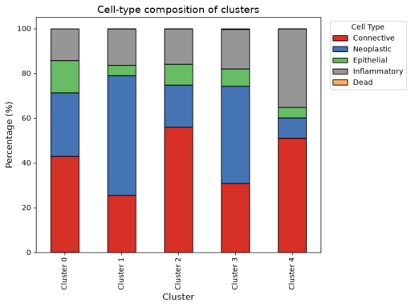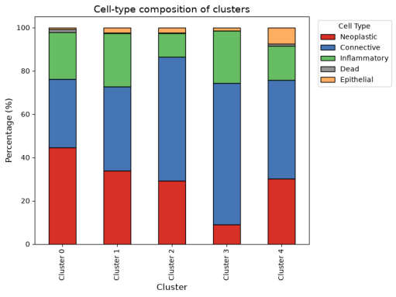
GIGA:
The analysis should identify clusters enriched in particular cell types, if supported by the results. It should also report whether the distributions are consistent across UNI, GIGA, and the different datasets.
Where cluster assignments differ between representations, the comparison should focus on the observed cell-type compositions rather than assuming that cluster identifiers correspond directly. For example, Cluster 1 in UNI does not necessarily represent the same group as Cluster 1 in GIGA.

5.4 MIL Survival-Analysis Results
The UNI and GIGA representations were evaluated using ABMIL and CLAM. The four combinations were compared using survival-analysis metrics.
C-index results:
UNI: ABMIL, CLAM
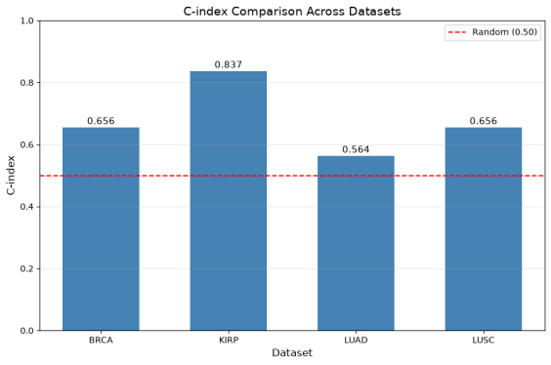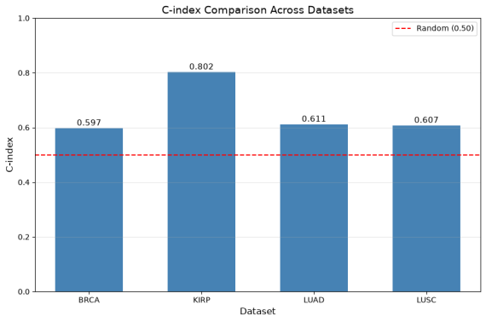
GIGA: ABMIL, CLAM
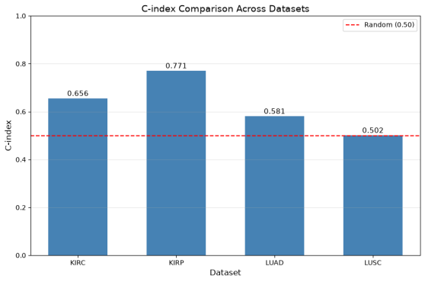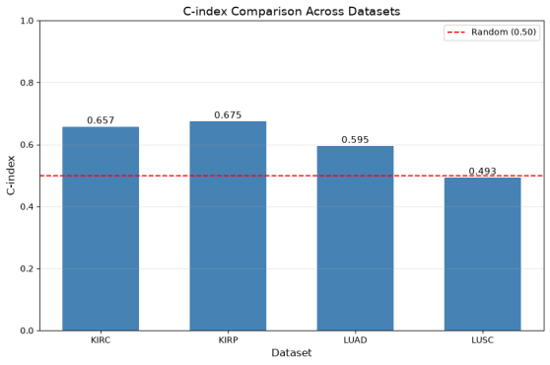

The C-index results should be used to compare the relative ranking performance of the four experimental combinations. The discussion should consider both the effect of the feature representation and the effect of the MIL method.
Cox loss results: [Insert the final training and/or evaluation loss values, clearly identifying the partition and epoch or checkpoint used.]
Cox loss should be interpreted in the context of the training procedure. A lower training loss alone is not sufficient to establish that a model generalizes better to unseen patients.
UNI: ABIML, CLAM
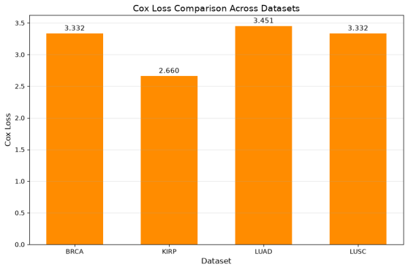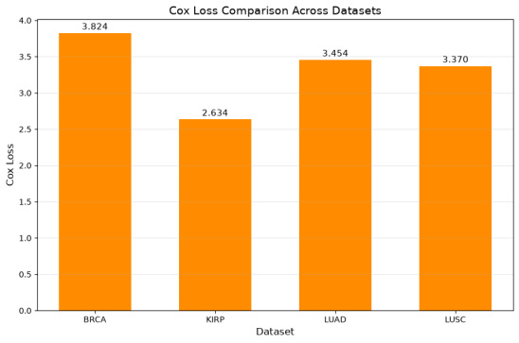
GIGA: ABMIL, CLAM
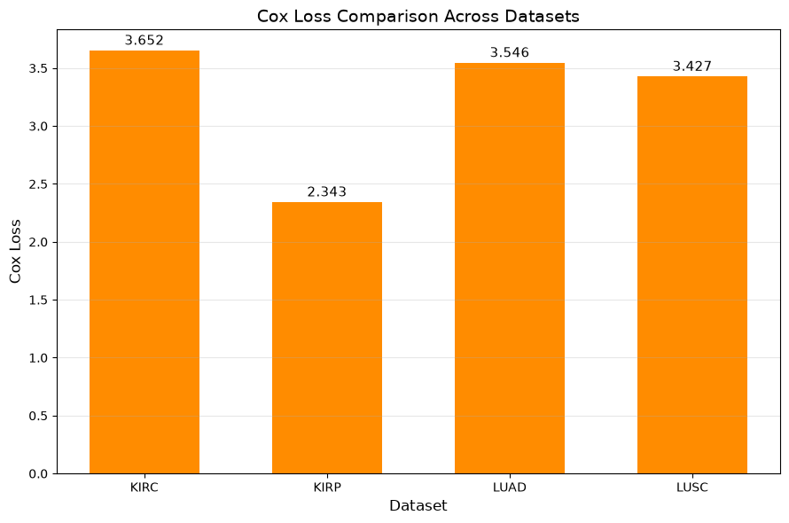
Kaplan–Meier findings: [Insert observations from the final survival curves, including the risk-group definition and any statistical comparison performed.]
The survival curves should be interpreted together with the C-index and other available evidence. Visual separation alone does not establish statistical significance.

UNI: BRCA, KIRP, LUAD, LUSC
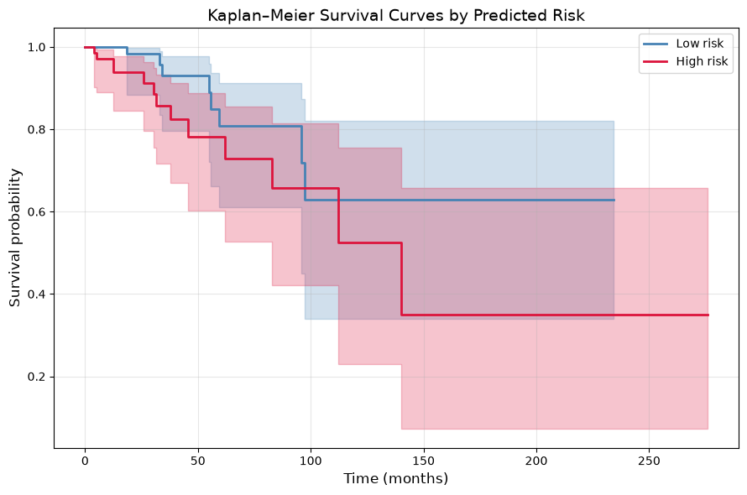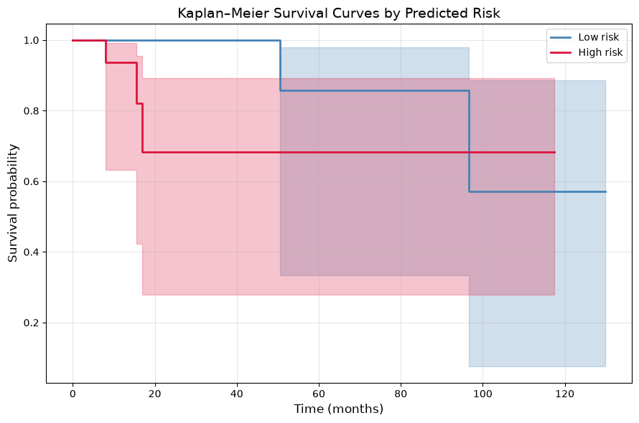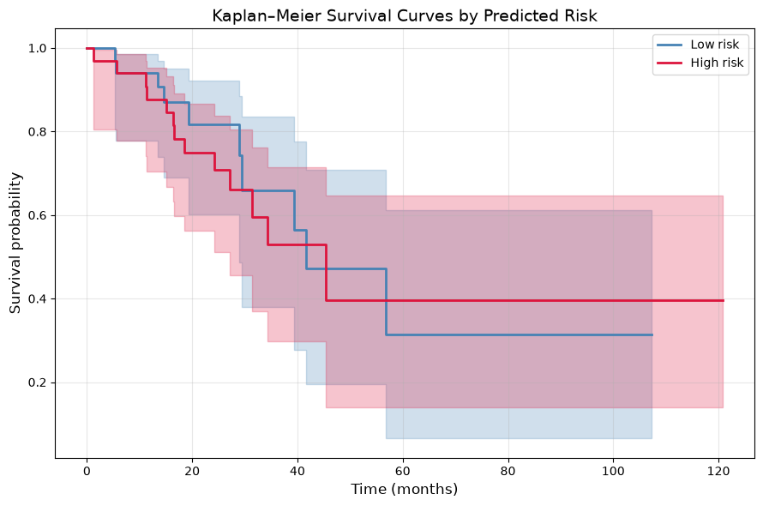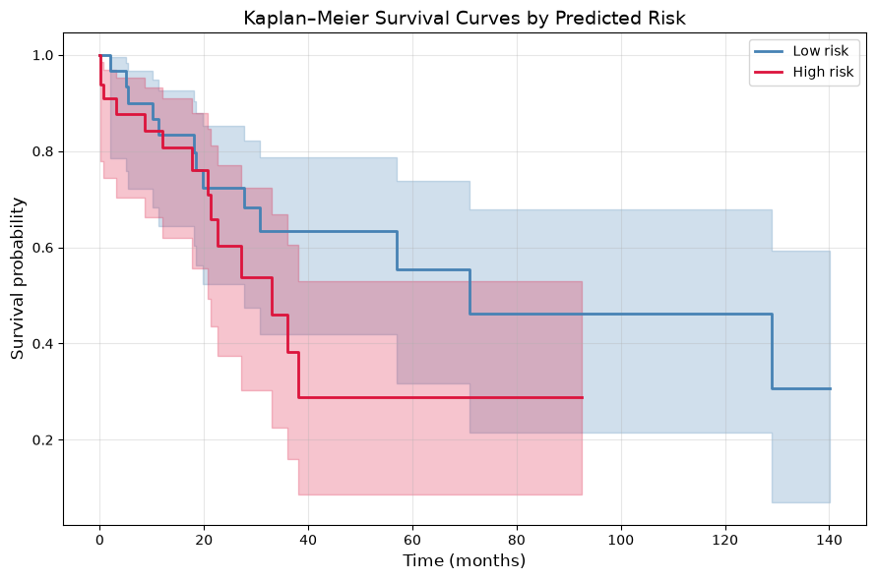
GIGA: KIRC, KIRP, LUAD, LUSC
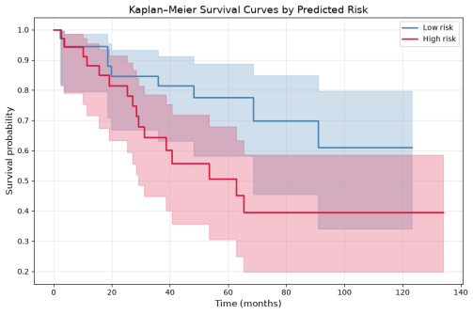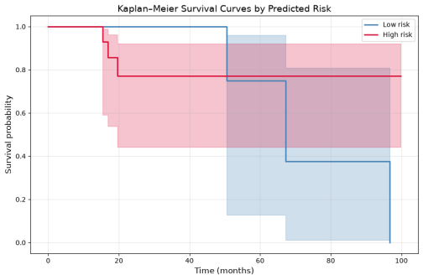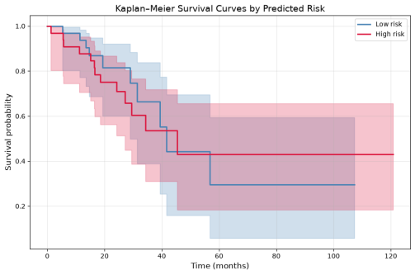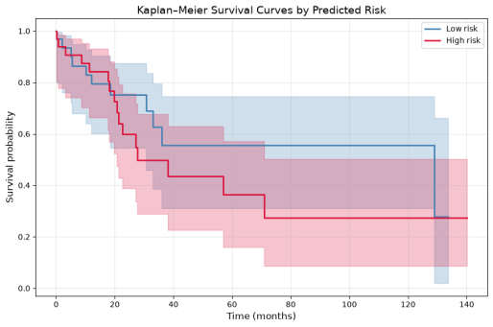

6. Discussion

6.1 Overall Interpretation of the Results
This project evaluated UNI and GIGA feature representations from three complementary perspectives: feature-space structure, biological composition, and downstream survival analysis.
The clustering results show that neither representation consistently forms five clearly separated clusters corresponding to the five CellViT cell types. The silhouette scores are generally low, with UNI showing particularly weak separation for the LUSC dataset. GIGA generally achieves higher and consistently positive silhouette scores across the evaluated datasets, indicating better geometric separation than UNI under the K-Means configuration used in this study.
However, these results should not be interpreted as evidence that the UNI and GIGA representations are poor representations of the histopathological images. A low silhouette score indicates that the embeddings do not naturally separate into the five predefined clusters. It does not indicate that the embeddings contain little or no useful information.
Histopathological images contain complex and heterogeneous tissue structures. A single image patch can contain multiple cell types and tissue patterns, meaning that the corresponding feature representation may also encode information from several biological components rather than forming completely separate groups.
Therefore, the clustering results mainly indicate that cell-type information is not strongly separated in the feature space according to the chosen K-Means configuration.

6.2 PCA and Silhouette Analysis
The PCA visualizations show different distributions of the feature representations across the datasets.
For UNI, some datasets show relatively distinct structures, while others contain substantial overlap between clusters. The silhouette scores support this observation. For example, the UNI LUSC dataset has a negative silhouette score, indicating poor cluster separation, while KIRP has the highest UNI silhouette score among the evaluated UNI datasets.
GIGA generally shows more clearly organized structures in the PCA plots. Its silhouette scores are also positive for all four evaluated datasets, with the highest value observed for KIRC.
Overall, the clustering analysis suggests that GIGA provides more consistently separated feature representations under the selected K-Means setup. However, the absolute silhouette scores remain relatively modest, indicating that neither representation produces strongly separated five-cluster structures.
This finding should therefore be interpreted as a difference in feature-space organization, rather than a direct measure of overall representation quality.

6.3 Biological Interpretation Using CellViT
The comparison with CellViT provides an additional perspective beyond purely mathematical clustering metrics.
The cluster-composition analysis shows that the clusters contain mixtures of different cell types. Some clusters are enriched in particular cell types, while others contain a more balanced combination.
This indicates that the embeddings contain information related to cellular composition, but the information is not organized into perfectly isolated cell-type groups.
This result is reasonable for histopathological data because tissue architecture is highly heterogeneous. Different cell types can occur in the same patch, and biological structures can overlap spatially. Consequently, expecting each feature-space cluster to correspond exactly to one cell type may be too restrictive.
The CellViT analysis therefore suggests that the feature representations capture some biologically meaningful structure, while that structure is more complex than a simple one-cluster-per-cell-type organization.

6.4 Downstream MIL and Survival Analysis
The MIL experiments provide an important complementary evaluation.
Both UNI and GIGA were combined with ABMIL and CLAM to evaluate their usefulness for survival analysis. The Kaplan–Meier curves show differences between predicted risk groups across several datasets, although the degree of separation varies between datasets and models.
More importantly, the C-index results are generally comparable between UNI and GIGA. This indicates that both representations contain information that can be used by MIL models to rank patients according to survival risk.
This is an important observation because it demonstrates that the clustering results alone do not fully describe the usefulness of the representations.
A representation may not produce strongly separated cell-type clusters but may still encode higher-level tissue patterns that are useful for patient-level survival analysis. Therefore, feature quality is task-dependent.
The Cox-loss results also show similar behavior between the corresponding UNI and GIGA experiments. However, Cox loss should primarily be interpreted as a training objective and should not be used alone to determine which representation is better.

6.5 Relationship Between Clustering and Survival Results
One of the main findings of this project is the difference between the clustering and survival-analysis results.
The clustering experiments show relatively limited separation between the five clusters, whereas the MIL experiments demonstrate that both representations can provide useful information for survival analysis.
This suggests that the information required for survival prediction is not necessarily the same as the information required to produce clearly separated cell-type clusters.
For example, survival prediction may depend on broader tissue characteristics, tumor architecture, cellular interactions, and spatial patterns rather than simply identifying individual cell types.
Therefore, a representation should not be considered ineffective solely because it does not produce strongly separated cell-type clusters.
The results support the importance of multi-task evaluation of feature representations. Clustering, biological interpretation, and downstream survival analysis provide different views of the same representations.

6.6 Limitations
Several limitations should be considered.
First, the number of clusters was fixed at K = 5 based on the five cell types provided by CellViT. This does not necessarily mean that five is the optimal number of natural clusters in the feature space.
Second, the CellViT output is used as the ground-truth reference for the biological comparison. Since CellViT itself is a computational model, errors in cell detection or cell-type classification can affect the cluster-composition analysis.
Third, PCA provides only a low-dimensional visualization of high-dimensional embeddings. Apparent overlap or separation in the PCA plots may not fully represent the structure of the original feature space.
Fourth, the silhouette score evaluates geometric cluster separation. It does not directly measure biological relevance or downstream predictive performance.
Finally, the survival results depend on the available datasets, sample sizes, censoring patterns, and experimental configuration. Therefore, the observed performance should not automatically be generalized to other pathology datasets.

7. Conclusion
This project presented a comparative evaluation of UNI and GIGA feature representations for histopathological image analysis.
The representations were evaluated using K-Means clustering, PCA visualization, silhouette scores, CellViT-based cell-type composition analysis, and downstream survival analysis using ABMIL and CLAM.
The clustering experiments showed that the feature representations do not form strongly separated clusters corresponding directly to the five CellViT cell types. GIGA generally demonstrated better and more consistent clustering separation than UNI, as reflected by the silhouette scores. However, the relatively low silhouette values indicate that the biological structure of the embeddings is more complex than a simple separation into five cell-type groups.
The CellViT comparison showed that the clusters contain different mixtures of cell types, with some clusters showing enrichment for particular cell types. This suggests that the representations capture biologically relevant information, but that information is not completely separated according to individual cell types.
The downstream MIL experiments provide an important additional result. Both UNI and GIGA produced comparable C-index performance when used with ABMIL and CLAM. This indicates that both representations contain useful information for survival-risk ranking, despite the limited separation observed in the clustering experiments.
Therefore, the results do not indicate that UNI or GIGA are poor representations of histopathological images. Instead, they show that representation quality is dependent on the evaluation task. The embeddings may not strongly separate individual cell types while still capturing higher-level tissue and biological information that is useful for patient-level survival analysis.
Overall, GIGA showed an advantage in the clustering evaluation, while UNI and GIGA demonstrated similar downstream survival-analysis performance. Consequently, there is no clear evidence that one representation is universally superior. The results demonstrate the importance of evaluating histopathological feature representations using multiple complementary analyses rather than relying on a single clustering metric.

Final conclusion
UNI and GIGA both provide useful feature representations for histopathological image analysis. Although their embeddings do not form strongly separated clusters corresponding to the five CellViT cell types, they still contain meaningful information that can be exploited for downstream survival analysis. GIGA generally showed better clustering separation, while both representations achieved comparable C-index performance with ABMIL and CLAM. Therefore, the effectiveness of a feature representation should be evaluated according to the specific downstream task rather than by clustering performance alone.

